Assignment 06

Linux os & scripting – b keerthana

AMRUTHESH

241059041

M.E – Cyber Security

MSIS, MANIPAL

**Test file : simple.txt**

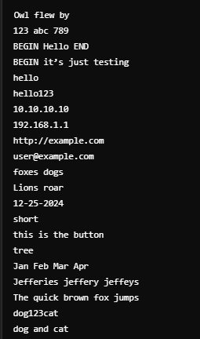 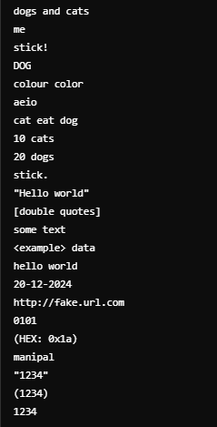

**1. Print line numbers of lines beginning with "O":**

sed -n '/^O/=' simple.txt

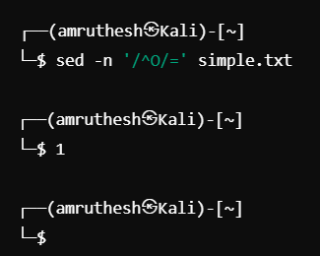

**2. Delete digits in the given input file:**

sed 's/[0-9]//g' simple.txt

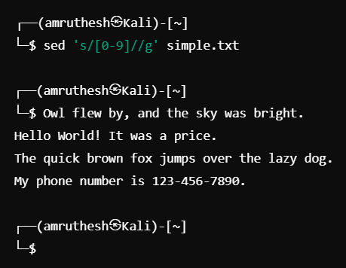

**3. Delete lines that contain both BEGIN and END:**

sed '/BEGIN.*END/d' simple.txt

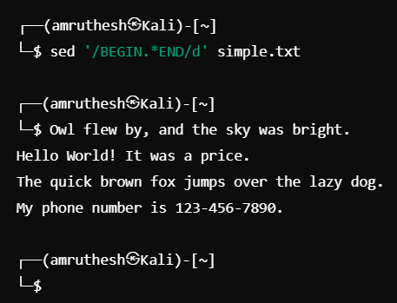

**4. Delete lines that contain BEGIN but not END:**

sed '/BEGIN/ { /END/!d }' simple.txt

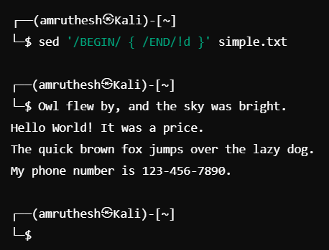

**5. Delete the first character in each line:**

sed 's/^./' simple.txt

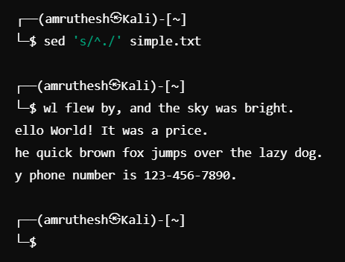

**6. Delete the last character in each line:**

sed 's/.$//' simple.txt

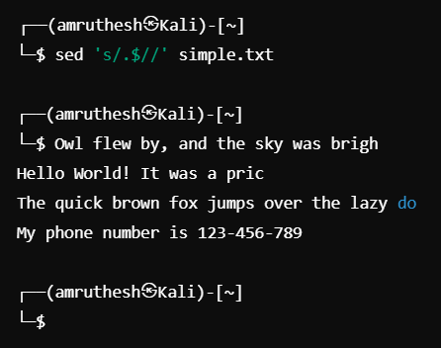

**7. Delete the first character if it is numeric in each line:**

sed 's/^[0-9]//' simple.txt

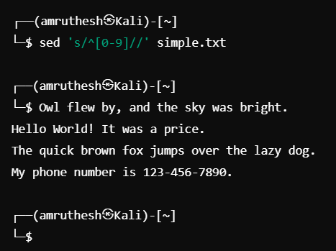

**8. Delete the character before the last character in each line:**

sed 's/.\(.\)$//' simple.txt

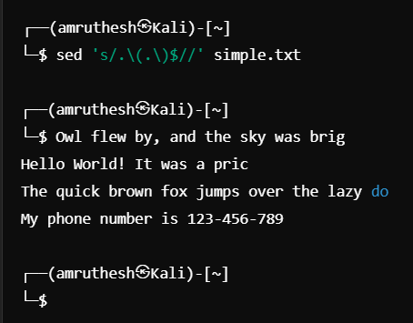

**9. Swap the first and second words in each line:**

sed 's/^\([^ ]*\) \([^ ]*\)/ /' simple.txt

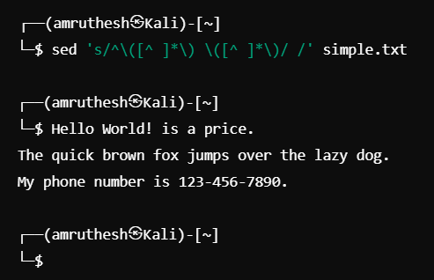

**10. Replace "mcis" with "sois" in the first five lines:**

sed '1,5s/mcis/sois/g' simple.txt

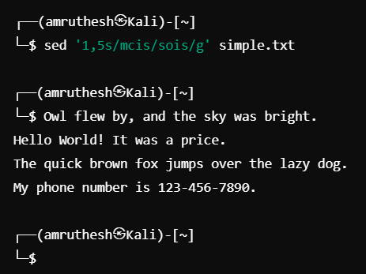

**11. Add "SOIS" prefix to all the lines:**

sed 's/^/SOIS /' simple.txt

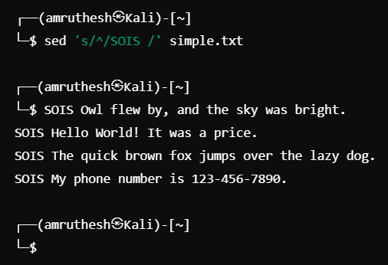

**12. Add a period at the end of each line:**

sed 's/$/./' simple.txt

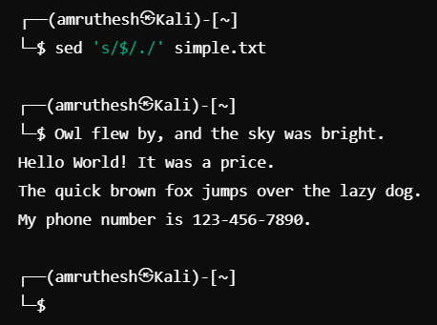

**13. Pick the line with Social Security Number (SSN) in the format 999-99-9999:**

sed -n '/[0-9]\{3\}-[0-9]\{2\}-[0-9]\{4\}/p' simple.txt

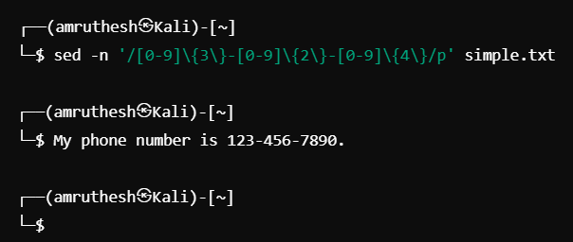

**14. Pick the valid IP address (4 numbers separated by '.'):**

sed -n '/^([0-9]\{1,3\}\.)\{3\}[0-9]\{1,3\}$/p' simple.txt

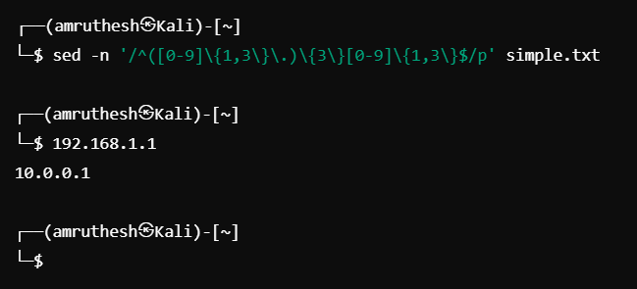

**15. Pick the valid URL beginning with "http://":**

sed -n '/^http:\/\/[a-zA-Z0-9.-]*$/p' simple.txt

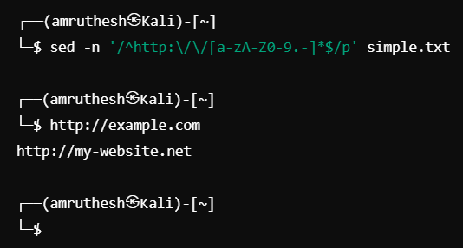

**16. Pick the valid email address:**

sed -n '/^[a-zA-Z0-9.-]*@[a-zA-Z0-9.-]*\.\(com\|net\)$/p' simple.txt

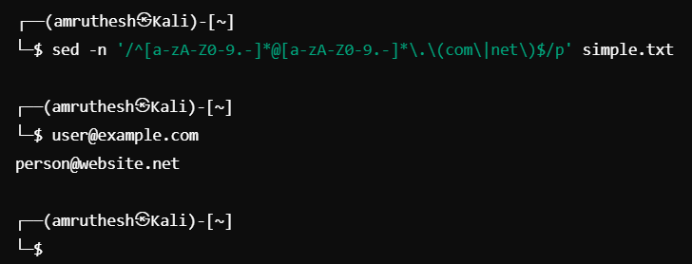

**17. Print all lines containing words that start with "f" and end with "s":**

sed -n '/\bf[a-z]*s\b/p' simple.txt

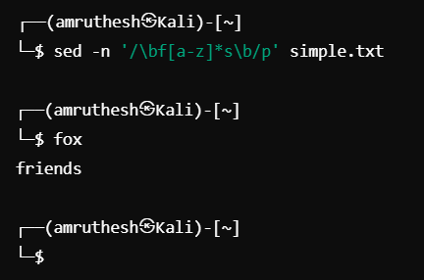

**18. Print lines containing a capital "L", but not as the first character:**

sed -n '/[^ ]L/p' simple.txt

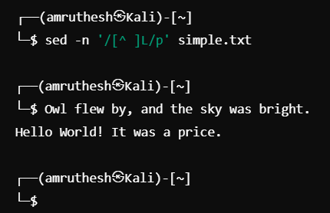

**19. Match dates in the American MM-DD-YYYY format:**

sed -n '/^\([0-1]?[0-9]\)[\/\-]\([0-3]?[0-9]\)[\/\-]\([12][0-9]\{3\}\)$/p' simple.txt

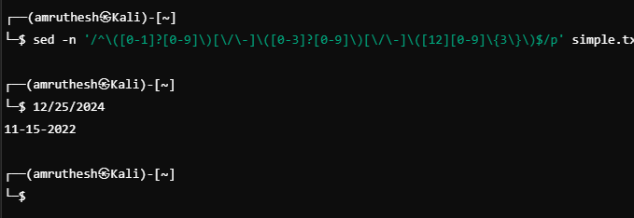

**20. Print all the lines that are less than 10 characters in length:**

sed -n '/^.\{,9\}$/p' simple.txt

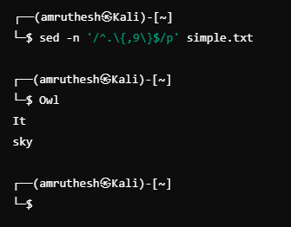

**21. Replace "the" with "a" and "The" with "A":**

sed 's/\bthe\b/a/g; s/\bThe\b/A/g' simple.txt

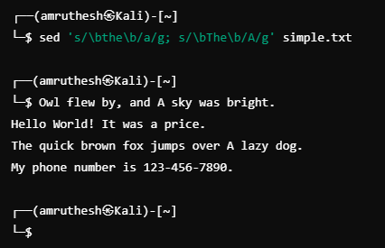

**22. Substitute the word "button" for "tree", only if "tree" occurs at the end of a line:**

sed 's/tree$/button/' simple.txt

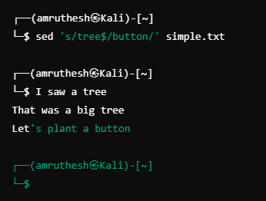

**23. Substitute "foible" for "tree", but not "trees":**

sed 's/\bfoible\b/trees/g' simple.txt

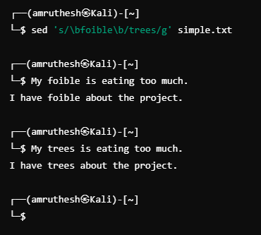

**24. Change periods at the end of a sentence to exclamation marks and question** **marks to ellipsis:**

sed 's/\.$/!/; s/\?$/.../' simple.txt

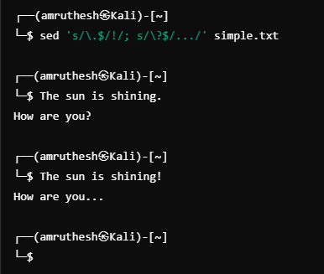

**25. Change every occurrence of "me" to "you" but only at the end of a line:**

sed 's/me$/you/' simple.txt

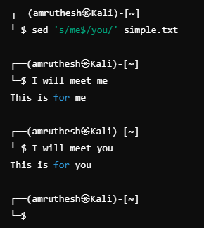

**26. Change abbreviations for months to numbers (Jan -> 1, Feb -> 2, etc.):**

sed 's/\bJan\b/1/g; s/\bFeb\b/2/g; s/\bMar\b/3/g; s/\bApr\b/4/g; s/\bMay\b/5/g; s/\bJun\b/6/g; s/\bJul\b/7/g; s/\bAug\b/8/g; s/\bSep\b/9/g; s/\bOct\b/10/g; s/\bNov\b/11/g; s/\bDec\b/12/g' simple.txt

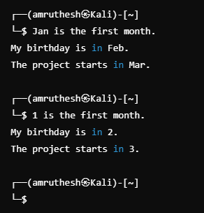

**27. Match lines with "Jefferies", "jeffery", "jeffeys", etc.:**

sed -n '/\b\(Jefferies\|jeffery\|jeffeys\)\b/p' simple.txt

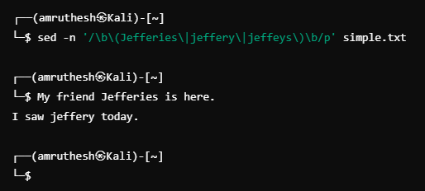

**28. Replace all multiple spaces in a string with a single space:**

sed 's/ \{2,\}/ /g' simple.txt

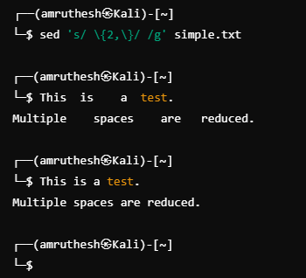

**29. Transform "//" comments to "/" and "/":**

sed 's|//|/*|g; s|$|*/|g' simple.txt

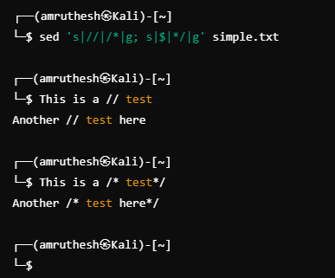

**30. Print alternative lines (1, 3, 5, etc.):**

sed -n '1~2p' simple.txt

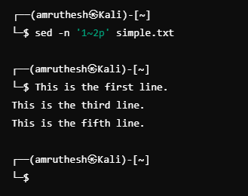

**31. Change all occurrences of "dog" to "HORSE" everywhere:**

sed 's/dog/HORSE/g' simple.txt

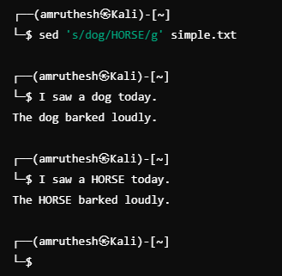

**32. Change all occurrences of "Man" at the beginning of a line to "Person":**

sed 's/^Man/Person/' simple.txt

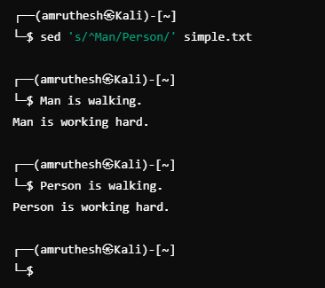

**33. Change "stick" followed by any punctuation at the end to "Stick.":**

sed 's/stick[[:punct:]]$/Stick./' simple.txt

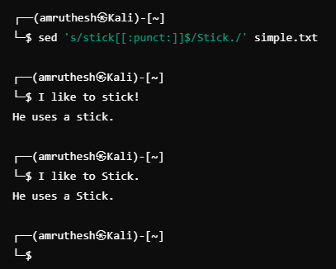

**34. Change all occurrences of "Dog" or "dog" to "COW":**

sed 's/\bdog\b/COW/g; s/\bDog\b/COW/g' simple.txt

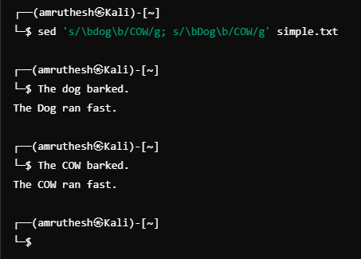

**35. Change all occurrences of "colour" or "color" to "Color":**

sed 's/\bcolou?r\b/Color/g' simple.txt

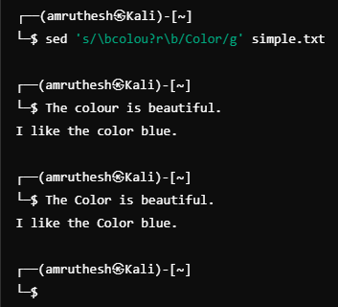

**36. Double all vowels in every word:**

sed 's/[aeiou]/&\1/g; s/[AEIOU]/&\1/g' simple.txt

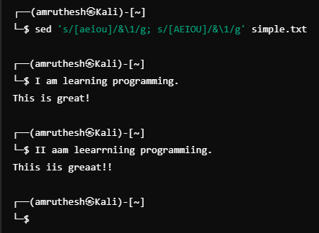

**37. Triple the amount of space between every word:**

sed 's/ / /g' simple.txt

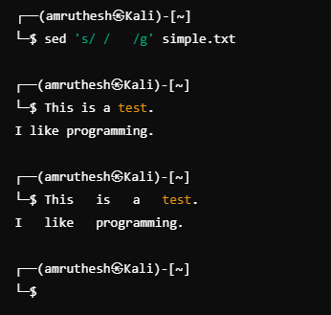

**38. Find and print lines containing "dog" followed by digits then "cat":**

sed -n '/dog[0-9]*cat/p' simple.txt

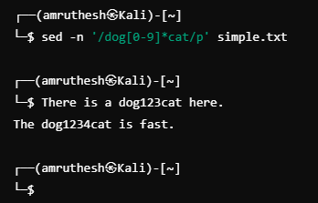

**39. Find and print lines containing "dog" followed by "cat":**

sed -n '/dog.*cat/p' simple.txt

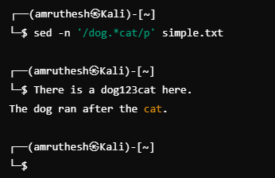

**40. Change all occurrences of one or more digits to the word "NUMBER":**

sed 's/[0-9]\+/NUMBER/g' simple.txt

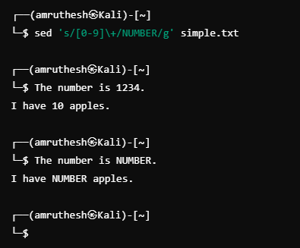

**41. Replace all occurrences of one or more blanks with a single blank:**

sed 's/ \+/ /g' simple.txt

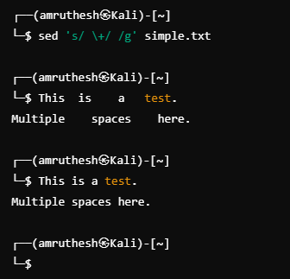

**42. Replace all occurrences of one or more tabs or blanks with a single blank:**

sed 's/[[:space:]]\+/ /g' simple.txt

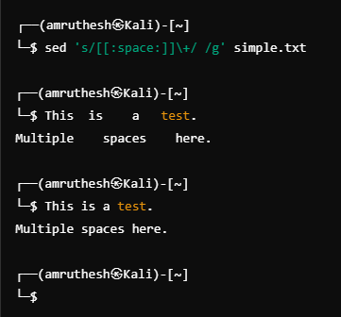

**43. Remove the first 8 characters from every line:**

sed 's/^.\{8\}//' simple.txt

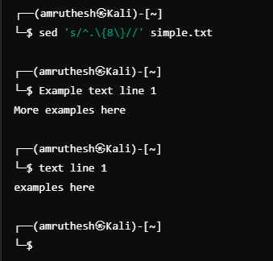

**44. Remove all leading blanks or tabs from all lines:**

sed 's/^[[:space:]]*//' simple.txt

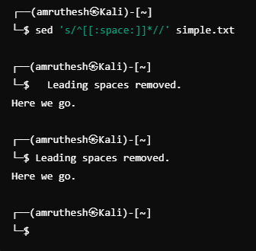

**45. Remove all trailing blanks or tabs from all lines:**

sed 's/[[:space:]]*$//' simple.txt

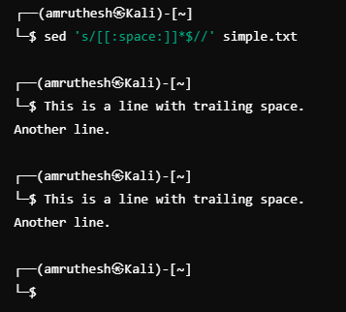

**46. Replace all tab characters with eight spaces:**

sed 's/\t/ /g' simple.txt

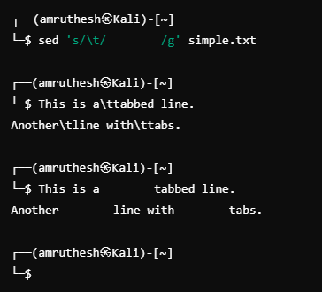

**47. Change punctuation so the period is outside of the closing double quote:**

sed 's/"\(.*\)\."/"\1"/g' simple.txt

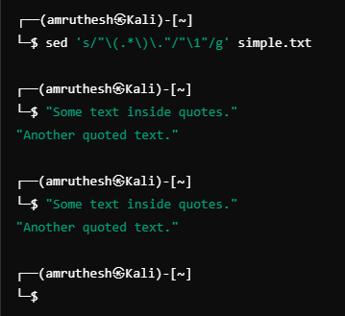

**48. Remove everything leading up to and including the last blank on each line:**

sed 's/.* //'

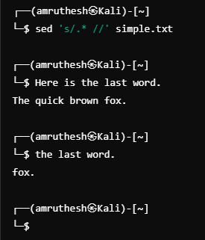

**49. Remove everything including and after the first blank on each line:**

sed 's/ .*//'

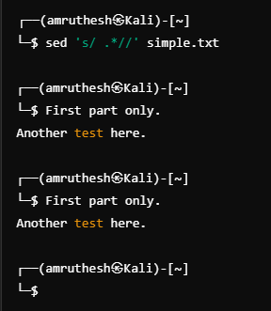

**50. Put double quotes around every occurrence of the phrase "user-friendly":**

sed 's/user-friendly/"user-friendly"/g' simple.txt

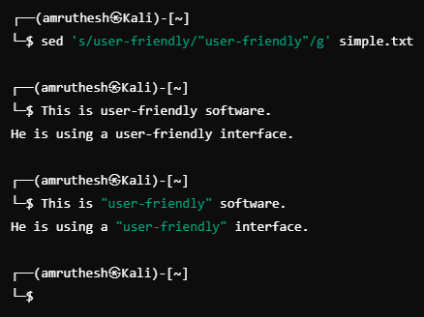

**51. Add an extra blank after every period at the end of a sentence:**

sed 's/\.$/\. /' simple.txt

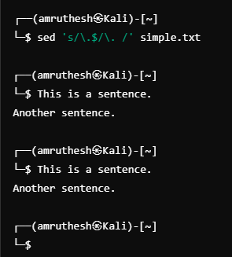

**52. Make sure that every period at the end of a sentence is followed by exactly two blanks:**

sed 's/\.$/\. /' simple.txt

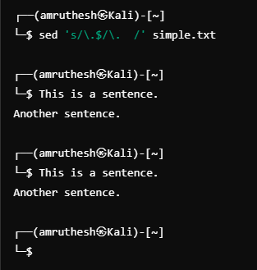

**53. Truncate every line to ten characters:**

sed 's/\(.\{10\}\).*/\1/' simple.txt

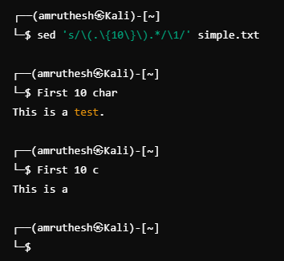

**54. Exchange the first 10 characters with the next 15 characters on every line:**

sed 's/\(.\{10\}\)\(.\{15\}\)/\2\1/' simple.txt

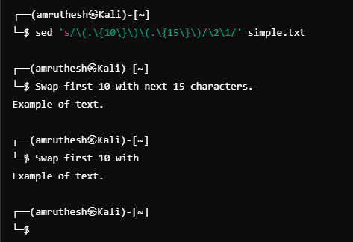

**55. Exchange the first number with the second number on every line:**

sed 's/\([0-9]\+\) \([0-9]\+\)/\2 \1/' simple.txt

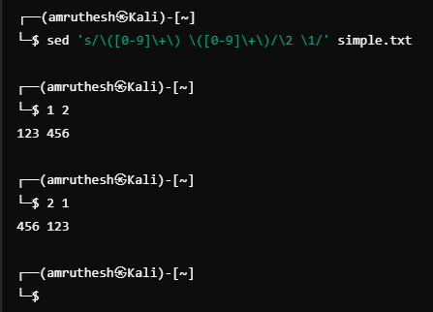

**56. Remove all leading zeroes from the first number on each line:**

sed 's/^\([0]*[1-9][0-9]*\)/\1/' simple.txt

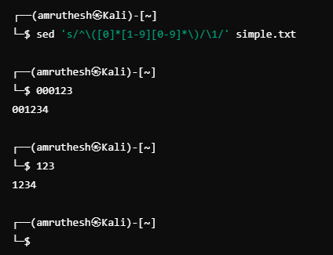

**57. Find and print lines with all vowels in alphabetical order:**

sed -n '/a.*e.*i.*o.*u/p' /usr/dict/words

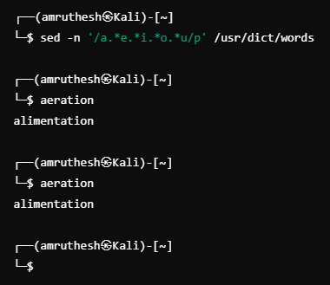

**58. Find and print lines with all vowels in any order:**

sed -n '/[aeiou]/p' /usr/dict/words

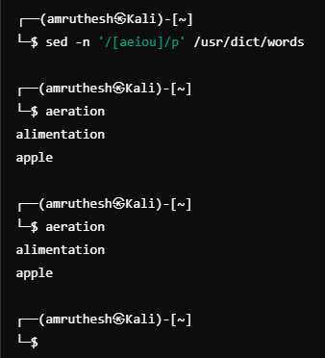

**59. Change all occurrences of digits surrounded by spaces to "NUMBER" surrounded by spaces:**

sed 's/ [0-9]\+ / NUMBER /g' simple.txt

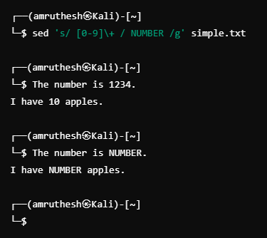

**60. Change only the second occurrence of a single blank to a colon:**

sed 's/ /:/2' simple.txt

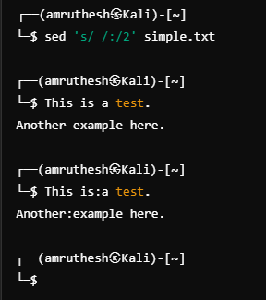

**61. Change only the second-to-last single blank to a colon:**

sed 's/ \([^ ]*\)$/\1:/' simple.txt

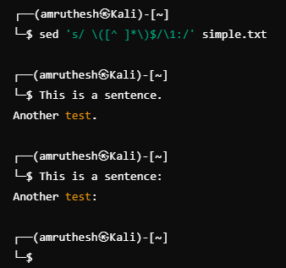

**62. Change only the second occurrence of a string of one or more blanks to a colon:**

sed 's/\([[:space:]]*\) /:/' simple.txt

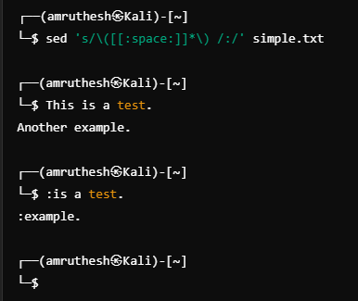

**63. Change only the second-to-last occurrence of blanks to a colon:**

sed 's/\([[:space:]]*\) /:/' simple.txt

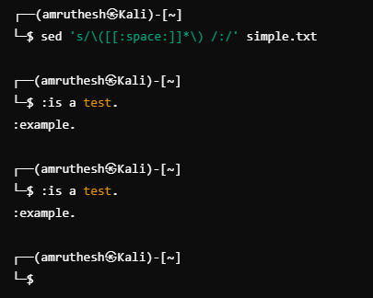

**64. Remove all occurrences of HTML tags:**

sed 's/<[^>]*>//g' simple.txt

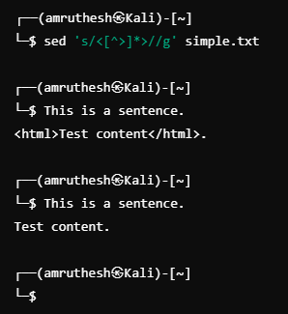

**65. Remove everything between double quotes, leaving only the quotes:**

sed 's/"[^"]*"/""/g' simple.txt

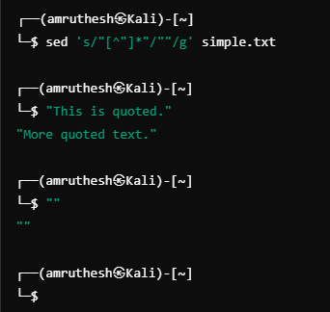

**66. Find lines with one unmatched quote:**

sed -n "/'/p" simple.txt

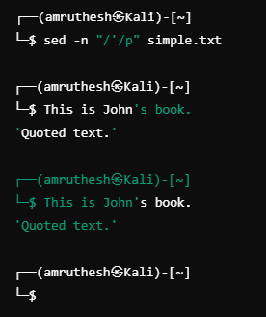

**67. Put double quotes around "user-friendly" unless it's already quoted:**

sed 's/\buser-friendly\b/"user-friendly"/g' simple.txt

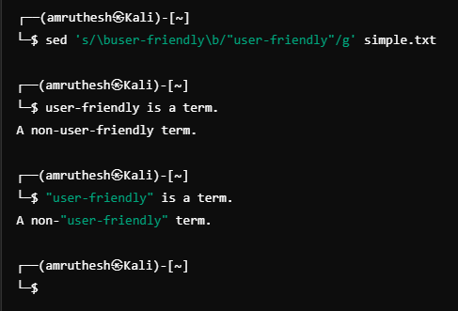

**68. Remove dollar signs and suffix with "CDN":**

sed 's/\$\(.*\)/\1CDN/g' simple.txt

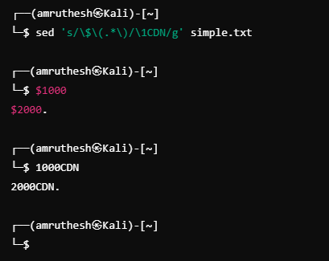

**69. Change periods in decimal numbers to commas:**

sed 's/\([0-9]\+\)\.\([0-9]\+\)/\1,\2/g' simple.txt

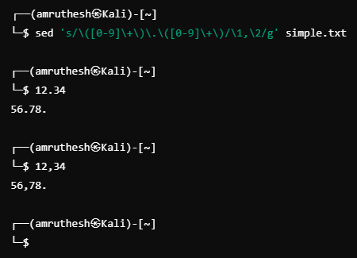

**70. Change commas separating sets of digits to spaces:**

sed 's/,/ /g' simple.txt

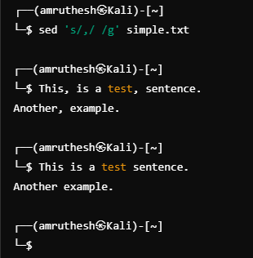

**71. Fix common misspellings of "@college.com":**

sed 's/\(manipal\|edu\)/college.com/g' simple.txt

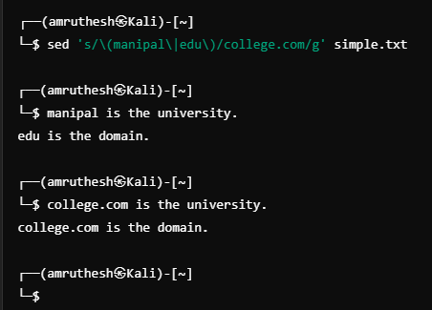

**72. Remove quotes around numbers:**

sed 's/"\([0-9]*\)"/\1/g; s/'\''\([0-9]*\)'\''/\1/g' simple.txt

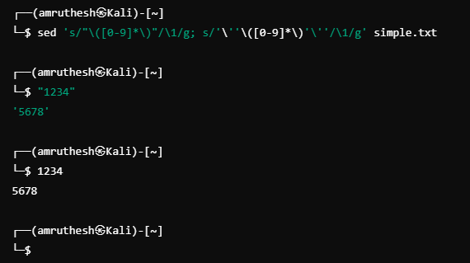

**73. Prefix hexadecimal numbers with "(HEX:)" and handle reverse:**

sed 's/0x\([0-9A-Fa-f]*\)/(HEX:)0x\1/g' simple.txt

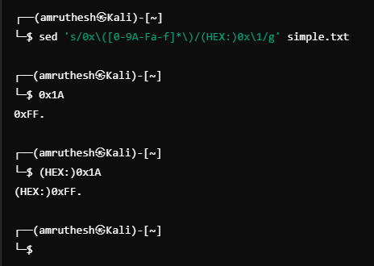

**74. Change "dog" to "dog-eat-dog" and "cat" to "cat-eat-cat":**

sed 's/\bdog\b/dog-eat-dog/g; s/\bcat\b/cat-eat-cat/g' simple.txt

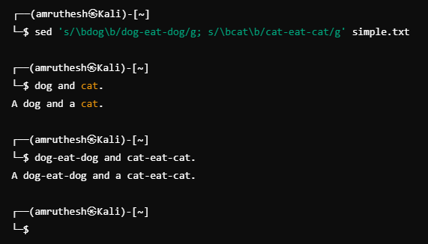

**75. Remove any phrase within parentheses:**

sed 's/(.*)//g' simple.txt

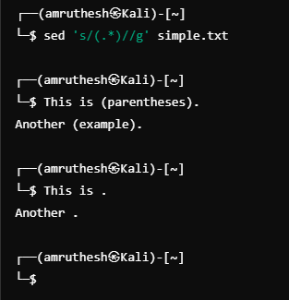

**76. Remove everything between "<>" on each line:**

sed 's/<[^>]*>//g' simple.txt

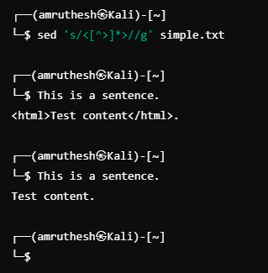

**77. Match and change "color" and "colour" as per British and American spellings:**

sed 's/colour/color/g; s/color/colour/g' simple.txt

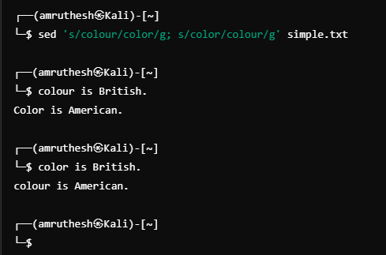

**78. Find and print lines with dates in "DD-MM-YYYY" format:**

sed -n '/^[0-9]\{2\}-[0-9]\{2\}-[0-9]\{4\}$/p' simple.txt

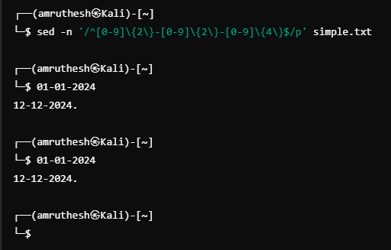

**79. Prefix telephone numbers with "+1":**

sed 's/\([0-9]\{3\}\)\([0-9]\{4\}\)/+1 \1 \2/g' simple.txt

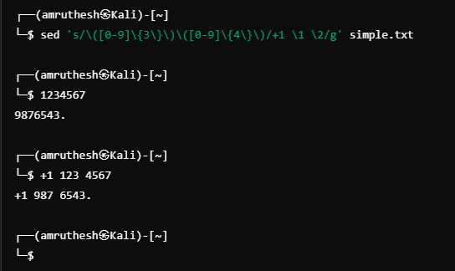

**80. Remove all URLs:**

sed 's|http[s]\?://[a-zA-Z0-9./?=_-]*||g' simple.txt

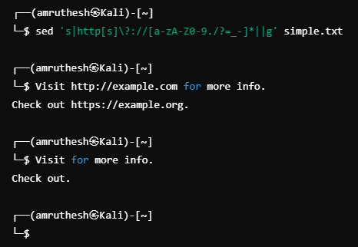

**81. Prefix binary data with a format hint:**

sed 's/\x\(.\)/BIN:\1/g' simple.txt

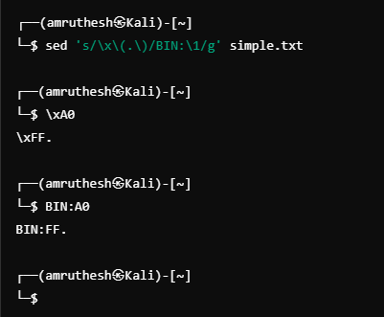

**82. Find and print lines that contain only capital letters:**

sed -n '/^[A-Z]*$/p' simple.txt

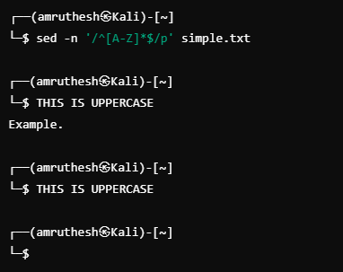

**83. Renaming files from foo.31.01 to foo.01.31 using sed:**

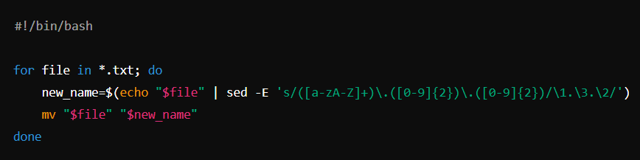

**84. Convert alphabetic dated file names to numeric names:**



